Concession Adjunct

✅ What Is a Concession Adjunct?
# Source: AI Source: Provided by: [Data Path: Persons Table -> ID Column: 1, Name_En Column: Motasem Essam] -> From: [Chatgpt (GPT-4-turbo)] on [8/6/2025]
A concession adjunct is a word, phrase, or clause that introduces an unexpected contrast to the main clause. It shows that the action of the main clause occurs despite something else being true.
It answers the question:
- Even though what?
- In spite of what?

🔸 Common Forms of Concession Adjuncts:
# Source: AI Source: Provided by: [Data Path: Persons Table -> ID Column: 1, Name_En Column: Motasem Essam] -> From: [Chatgpt (GPT-4-turbo)] on [8/6/2025]
- Conjunctions / Clauses: although, even though, though, while, whereas
- Prepositional Phrases: despite, in spite of
- Adverbials: however, nevertheless, still (as sentence adverbs)

🔸 Examples of Concession Adjuncts in Sentences:
# Source: AI Source: Provided by: [Data Path: Persons Table -> ID Column: 1, Name_En Column: Motasem Essam] -> From: [Chatgpt (GPT-4-turbo)] on [8/6/2025]
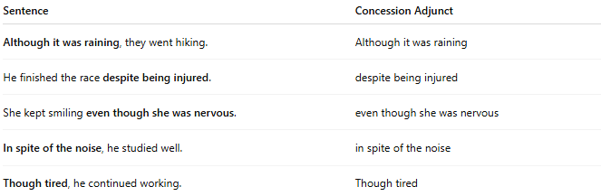
Sentence | Concession Adjunct
Although it was raining, they went hiking. | Although it was raining
He finished the race despite being injured. | despite being injured
She kept smiling even though she was nervous. | even though she was nervous
In spite of the noise, he studied well. | in spite of the noise
Though tired, he continued working. | Though tired

🔸 Position in the Sentence:
# Source: AI Source: Provided by: [Data Path: Persons Table -> ID Column: 1, Name_En Column: Motasem Essam] -> From: [Chatgpt (GPT-4-turbo)] on [8/6/2025]
- Initial: Even though she was late, they let her in.
- Final: They let her in even though she was late.

🔸 Reminder:
# Source: AI Source: Provided by: [Data Path: Persons Table -> ID Column: 1, Name_En Column: Motasem Essam] -> From: [Chatgpt (GPT-4-turbo)] on [8/6/2025]
A concession adjunct is optional and introduces contrast. It highlights the unexpectedness or surprising nature of the action.
🟢 "She kept smiling."
🟡 "She kept smiling even though she was nervous." → Adds contrast

